okf’kZd ijh{kk 2015&16
d{kk & 1 ¼igyh½
le; & $2\frac{1}{2}$ ?k.Vk fo’k; & xf.kr iw.kkZad & 30
ukekad % vadks esa -----------------------------------------------------------------------------------------------------------------------------------------
“kCnksa esa ----------------------------------------------------------------------------------------------------------------------------------------
ijh{kk fnu o fnukad ---------------------------------------------------------------------------------------------------------------
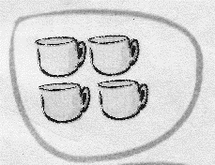
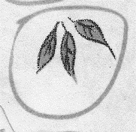
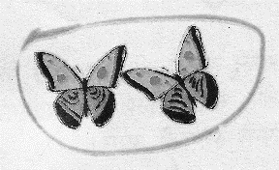
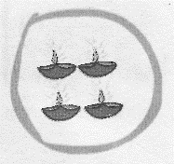
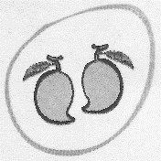
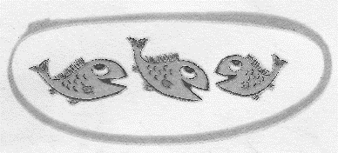
- cjkcj tksM+s cukvks&

- vad feykvks&
11 17
17 11
19 15
15 19
- fxudj feyku djks&
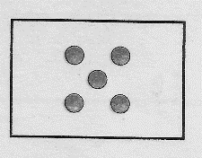

4

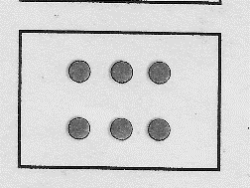

5

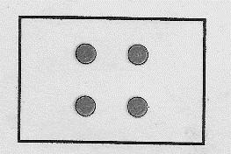

6

- fxudj jax Hkjks&
6
P.T.O.
- lgh mÙkj okyh ia[kqfM+;ksa esa jax Hkjks&
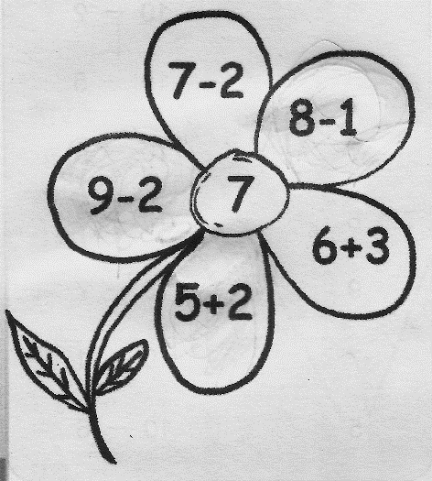

- fxuks vkSj la[;k fy[kks&
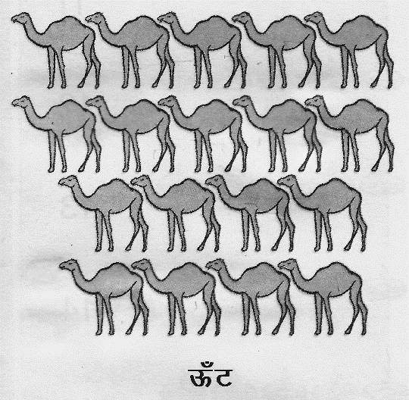

………………………………

- eSa dgka ij gw¡\
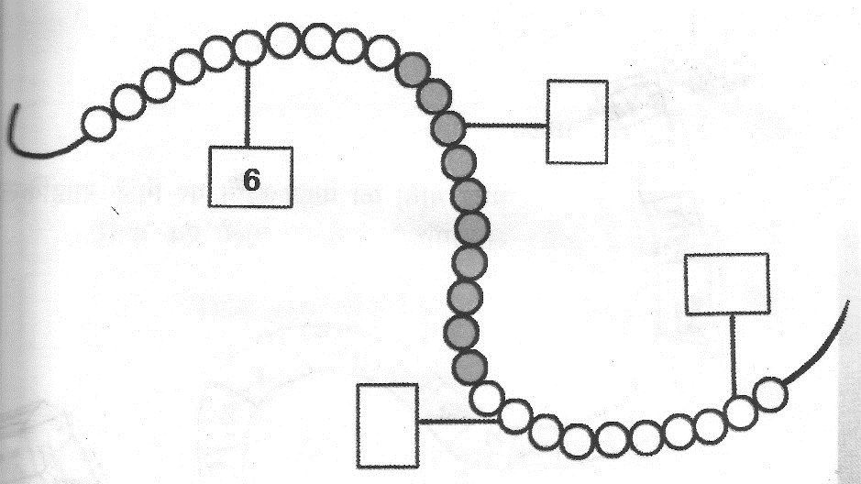
- igys dh la[;k fy[kks&
---------------------------------------------- 11
---------------------------------------------- 16
---------------------------------------------- 20
- Ldwy esa 10 dqflZ;k¡ FkhaA xq:th 3 dqflZ;k¡ vkSj [kjhn yk,A vc fdruh dqflZ;k¡ gks xbZa\

------------------------------------------------------------------------------------------------------------------------------------------------------------------------

- gkfen ds ikl 7 :i;s FksA mlus 3 :i;s dh ck¡lqjh [kjhnhA vc mlds ikl fdrus :i;s cps\

-----------------------------------------------------------------------------------------------------------------------------------------------------------------------

